Building At Khar.
1. Project Information
- Project Name: The Celeste
- Location: __________________
- Plot Area: __________________
- Built-up Area: __________________
- Project Type: High-rise residential and commercial development
- Client/Developer: Transindia Group
- Status: __________________
- Completion Year: __________________

2. Project Overview
The Celeste is a contemporary high-rise development featuring premium residences with commercial spaces at street level. The building is defined by its flowing balcony profiles, rounded façade corners and extensive glazing. Integrated lighting, landscaped balconies and warm material accents give the tower a refined and distinctive urban identity.

3. Building Features
- Spacious projecting balconies with glass railings
- Curved and rounded façade geometry
- Floor-to-ceiling corner glazing
- Vertical dark-toned louver panels
- Warm wooden balcony ceilings
- Integrated balcony planters and greenery
- Continuous architectural façade lighting
- Ground-floor commercial frontage
- Prominent entrance canopy with illuminated signage
- Landscaped pedestrian and vehicular approach
- Large windows for natural light and exterior views
- Strong building branding at entrance and terrace level

4. Overall Design Concept
The design combines soft, flowing architectural forms with clean contemporary detailing. Repeated horizontal balcony bands are balanced by vertical glazing and louvered elements, creating rhythm and visual height. Warm timber finishes, transparent glass and integrated greenery soften the tower’s scale and establish an elegant residential character.

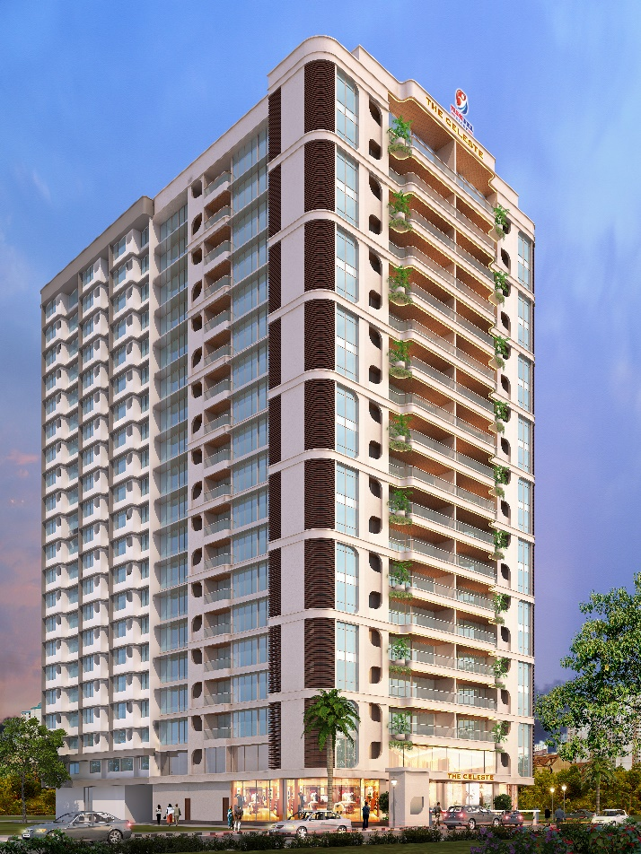  Image 1 | 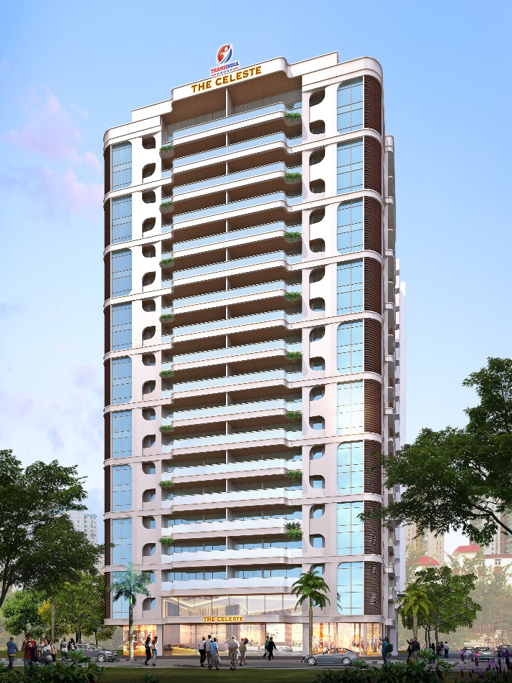  Image 2
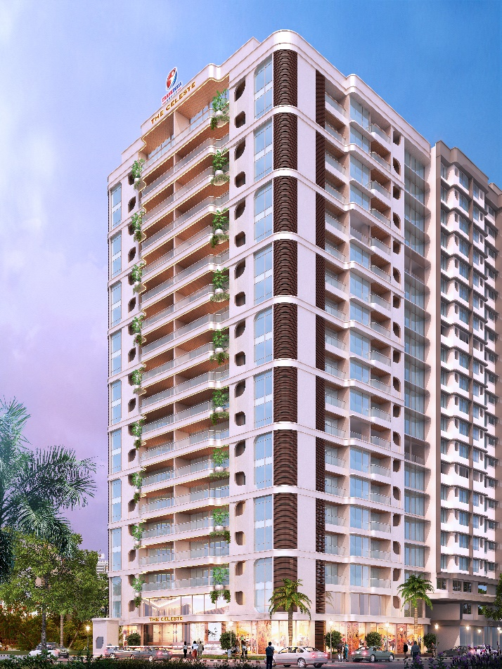  Image 3 | 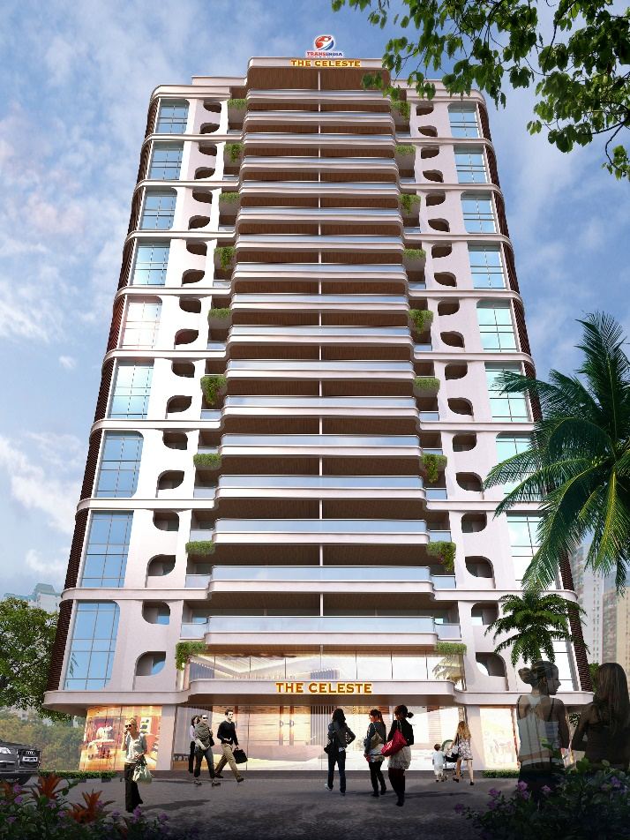  Image 4

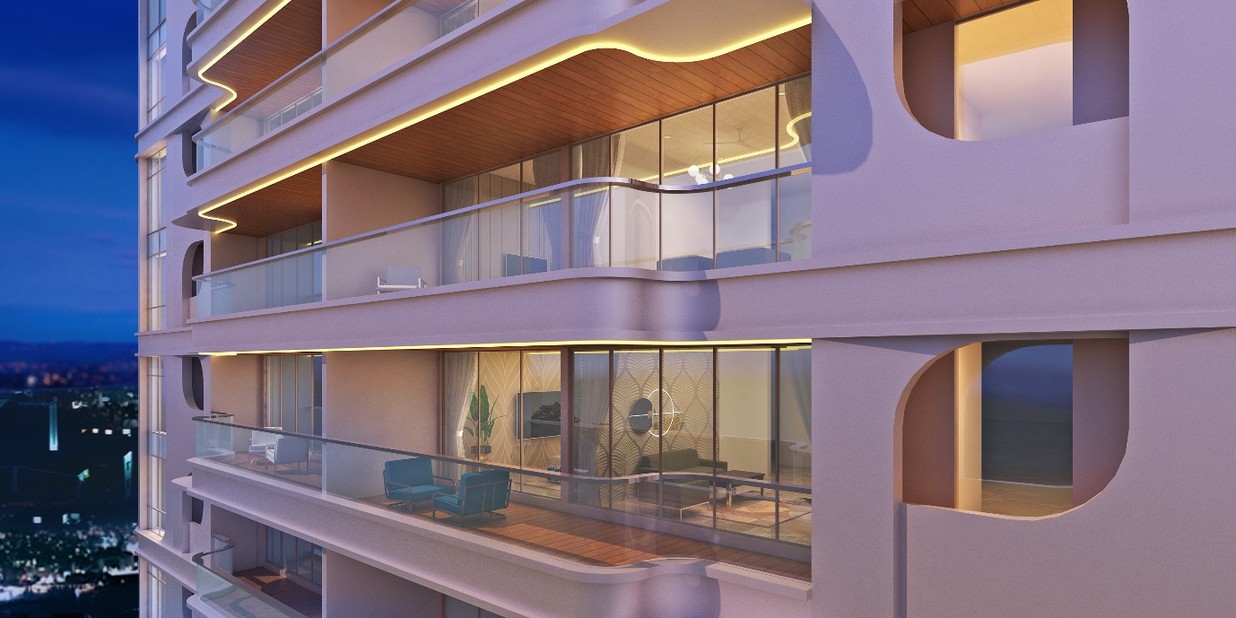
Image 5. Terrace.

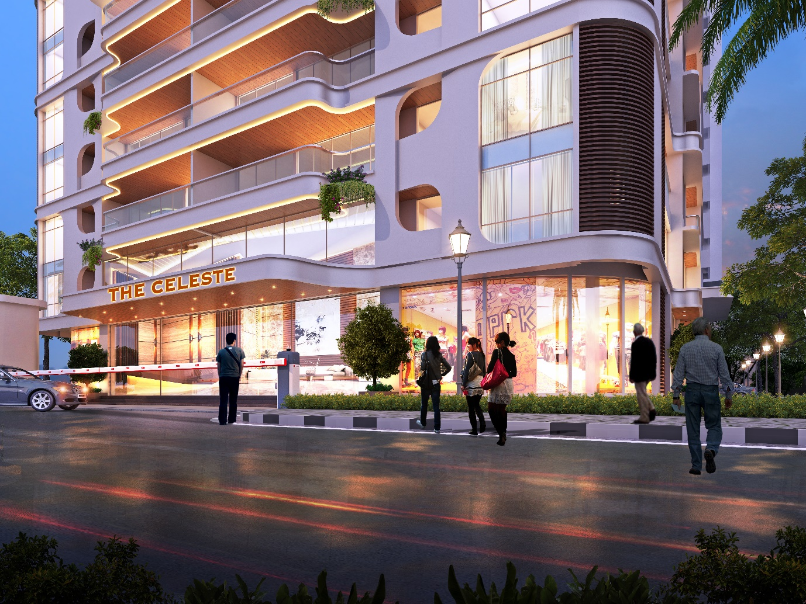
Image 6. Entrance Gate Night

